**Course Specialist Year 12 Test One 2022**

Student name: ________________ Teacher name: ________________

**Task type: Response**

**Time allowed for this task: _____40______ mins**

**Number of questions: _____8______**

**Materials required:** Calculator with CAS capability (to be provided by the student)

Standard items: Pens (blue/black preferred), pencils (including coloured), sharpener, correction fluid/tape, eraser, ruler, highlighters

Special items: Drawing instruments, templates, notes on one unfolded sheet of   
A4 paper, and up to three calculators approved for use in the WACE examinations

**Marks available: __42____ marks**

**Task weighting: _10___%**

**Formula sheet provided: Yes/No**

**Note: All part questions worth more than 2 marks require working to obtain full marks.**

Q1 (2, 3 & 3 = 8 marks)

Let  and .

Simplify the following.

1. 

|  |
| --- |
| **Solution** |
|  |
| **Specific behaviours** |
| 🗸 real part  🗸 imaginary part |

1. 

|  |
| --- |
| **Solution** |
|  |
| **Specific behaviours** |
| 🗸 shows use of conjugate  🗸 numerator  🗸 denominator |

1. 

|  |
| --- |
| **Solution** |
|  |
| **Specific behaviours** |
| P shows use of conjugate or uses result from b but only if conjugate shown  🗸 shows how to multiply numerators  🗸 simplified expression |

Q2 (3 marks)

Determine all possible real number pairs  such that 

|  |
| --- |
| **Solution** |
|  |
| **Specific behaviours** |
| 🗸 equates real and imaginary parts of two expressions  🗸 sets up two simultaneous equations  P solves for two exact pairs of values |

Q3 (3 marks)

Consider the polynomial  where  are real numbers.

Given that  and  determine the values of .

|  |
| --- |
| **Solution** |
|  |
| **Specific behaviours** |
| 🗸 uses conjugate root  🗸 solves for one constant  🗸 solves for all 3 constants |

Q4 (3 marks)

Using the diagram below determine the complex number  in exact cartesian form.

(Note: Not drawn to scale)

|  |
| --- |
| **Solution** |
|  |
| **Specific behaviours** |
| 🗸 determines argument of w  🗸 determines modulus of w  🗸 expresses in exact cartesian form |

Q5 (3 & 3= 6 marks)

Sketch the locus for the following labelling important features and points.

1. 

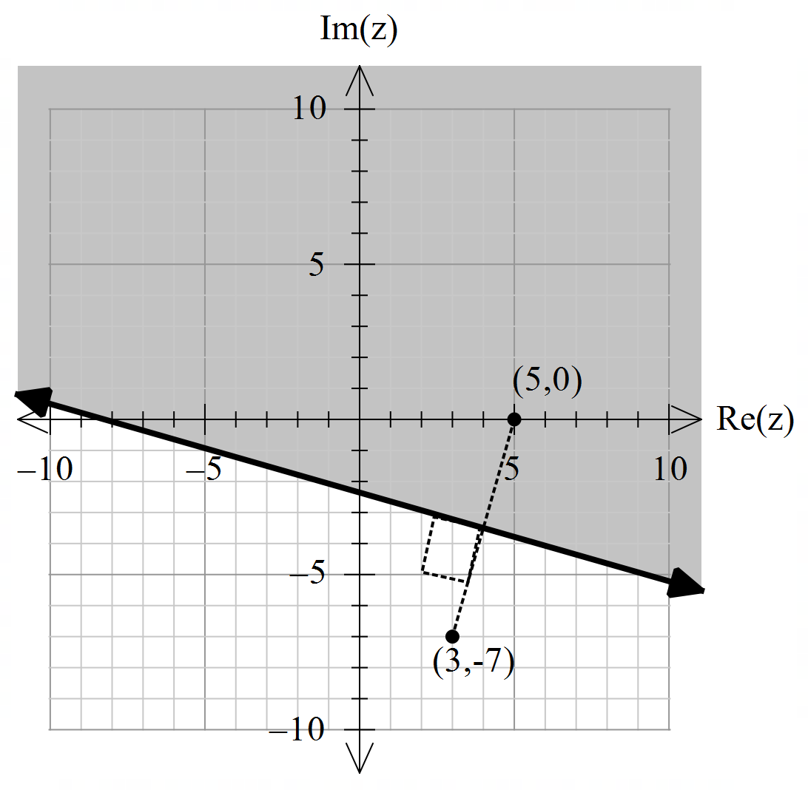

|  |
| --- |
| **Solution** |
|  |
| **Specific behaviours** |
| 🗸 plots endpoints  🗸 draws perpendicular bisector & indicates right angle  🗸 shades correct region |

1. 

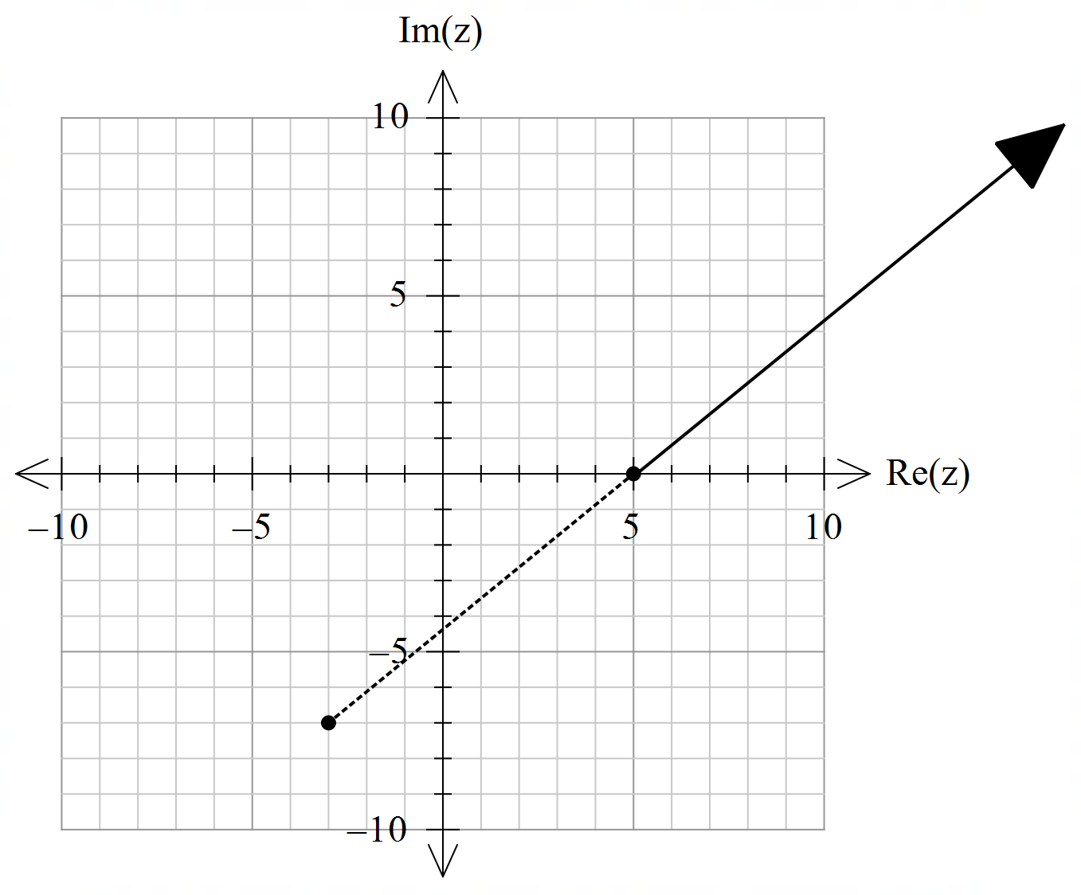

|  |
| --- |
| **Solution** |
|  |
| **Specific behaviours** |
| 🗸 plots pts (-3,-7) & (5,0)  🗸 shows dotted line between  🗸 plots locus line |

Q6 (2 & 4 = 6 marks)

Consider the set of points  in the complex plane such that .

1. 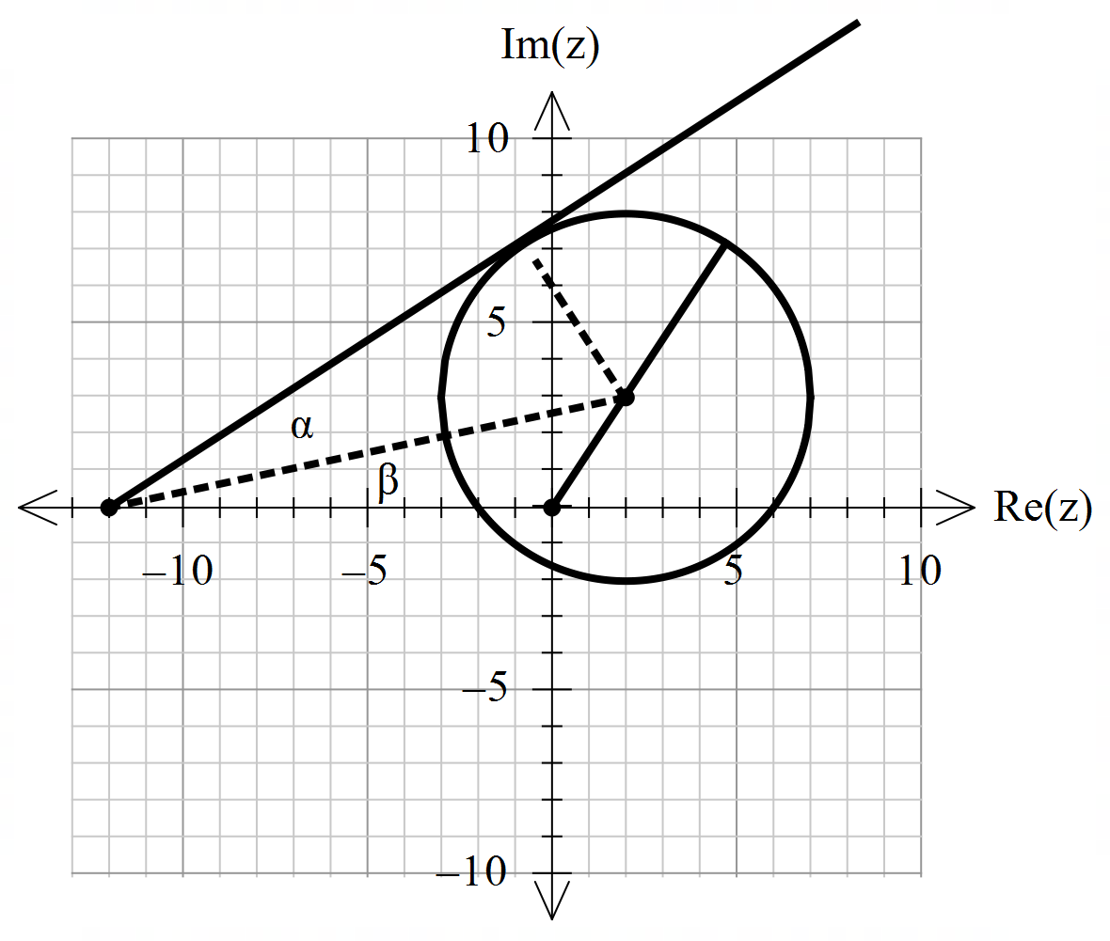Determine the maximum value of .



8.605551275

|  |
| --- |
| **Solution** |
|  |
| **Specific behaviours** |
| 🗸 determines modulus of centre  🗸 adds radius (approx.) |

1. Determine the maximum value of the .

|  |
| --- |
| **Solution** |
|  |
| **Specific behaviours** |
| 🗸 uses tangent line from (-12,0)  🗸 determines alpha angle  🗸 identifies right angle for beta triangle and determines two side lengths  P determines sum of alpha & beta angles (see diagram) |

Q7 (4 marks)

Using De Moivre’s Theorem, derive an expression for  in terms of .

|  |
| --- |
| **Solution** |
|  |
| **Specific behaviours** |
| 🗸 sets up equation for power 4 and uses De Moivre’s  🗸 states expression for power 4  🗸 equates imaginary parts of both sides  P states required expression |

Q8 (4, 2 & 3 = 9 marks)

1. Solve for all the roots  in polar form  with .

|  |
| --- |
| **Solution** |
|  |
| **Specific behaviours** |
| 🗸 converts RHS to polar  🗸 demonstrates use of De Moivre’s  🗸 determines modulus of all roots  P determines principal arguments |

1. Plot these roots on the complex plane below.

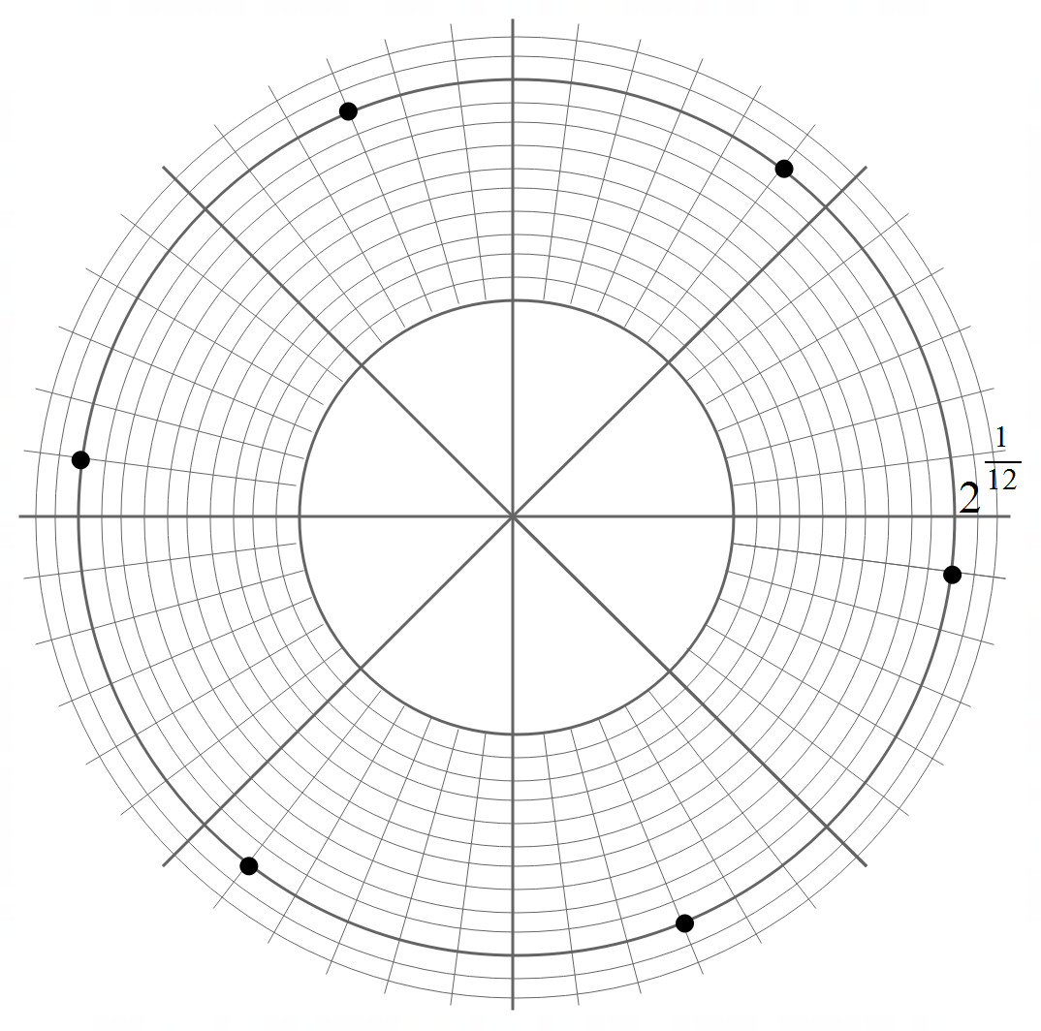

|  |
| --- |
| **Solution** |
|  |
| **Specific behaviours** |
| 🗸 shows scale and equally distance  🗸 all positions correct |

1. Adjacent points can be joined by lines to form a polygon. Determine the exact area of this polygon.

|  |
| --- |
| **Solution** |
|  |
| **Specific behaviours** |
| 🗸 identifies equilateral triangles  🗸 determines side lengths  🗸 shows calculation for total exact area |

Working out space

Working out space